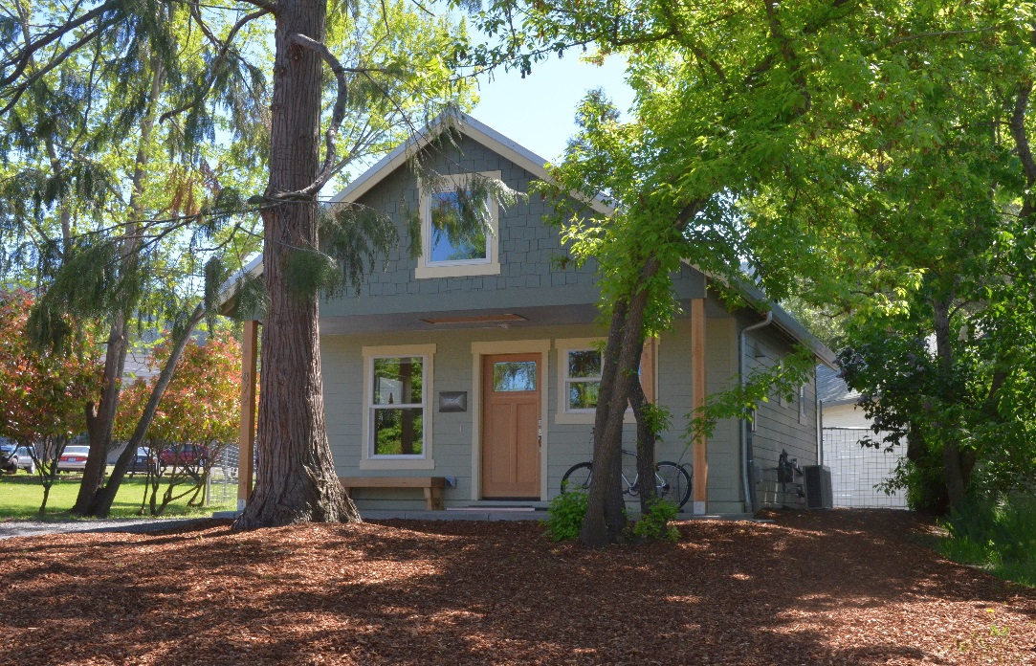

Historically Compatible New Single Family Residence

Location: 872 Siskiyou Boulevard
Owner: John Shrode
Contractor: Charlie Hamilton of Suncrest Homes

John Shrode is very much an ecologist therefore his dream was to build a small home in Ashland that was as energy efficient as possible and walkable both to his job at Southern Oregon University and to shopping. But like so many Ashlanders who share his wish to build a home he ran up against the difficulty of finding affordable property in a central location to build upon. John feels very fortunate that the perfect small lot came on the market right on Siskiyou Boulevard, just blocks from the University and downtown. He bought the property and started realizing his dream. The lot came with a unique set of restrictions, but John was able to work within the restrictions, leaving mature trees on the property and allowing space for a large garden area.

John basically designed his own home, but worked with Charlie Hamilton of Suncrest Homes to perfect his design and build it to be a model of energy efficiency and livability in just over 500 square feet. The home fits beautifully into its historic neighborhood and sets an example that hopefully many others will follow!

Congratulations, John, on realizing your dream, and Charlie for helping him make his dream come true.

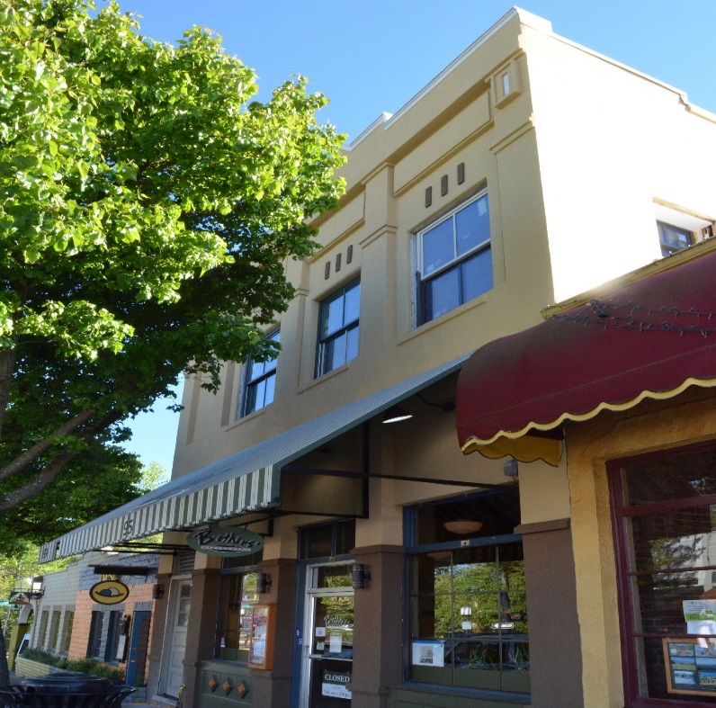
Bees, Bats and Bloomers at Brothers
Historically Compatible Commercial Building

Location: 95 N. Main
Owners: Daniel Durant & David Newton
Contractor: Donny Baldwin of Baldwin Construction Services
Architect: Matt Small of Kistler, Small, & White

In the January 7th, 1889 edition of the Tidings it was announced that
“Mrs. Josephine Crocker has put up a two-story brick building, the lower story of which is used for a store and the upper story for lodging rooms.”

Construction costs were estimated at $4,400. Mrs. Crocker was the principal of the Ashland College, a private educational facility. She apparently constructed the property as an investment and leased to various uses, the first being a harness maker and sewing machine company.

Mrs. Crocker sold the property in 1903 and Sanborn Fire insurance Maps document various uses over the decades. The September 20, 1946 edition of the Tidings states that the entire building was completely remodeled that past spring, with the final touch being added with the hanging of a large street sign, indicating it was then being the location of North Main Hardware.

Sadly, it was probably the 1946 remodel that was responsible for the removal of all of the significant original architectural details, which included the elaborately detailed brick cornice with whimsical bird house details, and the alteration of the rhythm and massing of the building by removing windows on the 2nd story and covering the original brickwork with stucco.

Flash forward through the decades to about 1975, when Brothers Restaurant is established to become a favorite eatery in the downtown area. Jump forward a few more decades to 2007, when Dan Durant and David Newton purchase Brothers and add new life and energy to a popular local breakfast and lunch landmark.

Realizing in 2014 that though they were growing their business and enjoying great success, the building that had been the location and home of Brothers for nearly 40 years, was in serious decline, to the degree that they would have to do something. Moving was out of the question. So with care and diplomacy, Dan and David were able to purchase the building from the elderly owners. Then the fun began.

One day while eating at Brothers, architect Matt Small overheard Dan lamenting the condition and the need to remodel the building. Feeling cheeky, Matt approached Dan initiating a conversation that has developed into a strong working relationship. That collaboration has created the plan and project that we are acknowledging and awarding today as a “Historically Compatible Commercial Building.”

Through the course of construction, contractor, Donny Baldwin and his crew made several interesting discoveries. During deconstruction of the 3 apartments on the second floor, the workmen discovered an abandoned bee hive in a wall that yielded 48 eight-ounce jars of honey.

The crew also uncovered a bat nest that was carefully removed and transported north to Wild Life Images for continued health and longevity.

But possibly more interesting and open to curious conjecture is the pair of women’s bloomer style underwear that was stuffed behind a door jamb as a wind breaker. Haven’t we all wondered what we would hear if walls could talk.

Back to the reason for our award……
The Historic Commission applauds the owners, contractor and design team for re-establishing design details that harken back to important buildings past, such as a new decorative cornice, enhanced column capitals and base detailing, and the addition of a window on the second floor - all of which enhances a long lost sense of rhythm to the face of the building. And don’t forget the whimsical addition of the ceramic bird house embellishments and the mix of Arabic and Roman numerals mounted on the new cornice, as well as the sunburst medallions mounted on the frieze below the cornice.

Congratulations for the results of this excellent project, and for adding another 100 years of life to this important building.

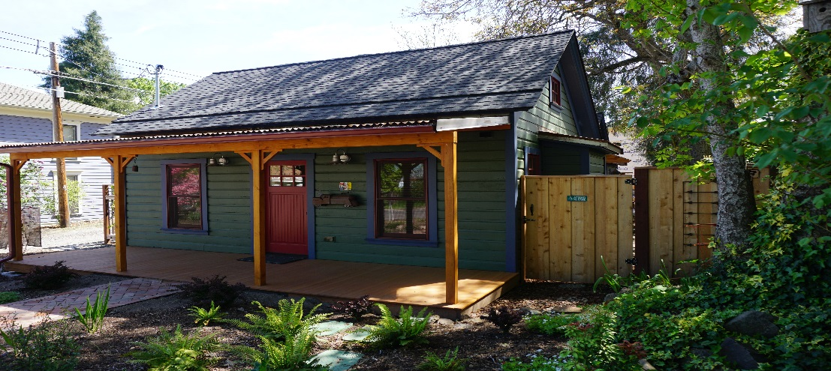
Historically Compatible Residential Addition

Location: 236 Fifth Street
Owners: Allison Renwick
Contractor: Tom Giacomini & Andy Lange of On Point Construction
Designer: Brint Borgilt of Nautilus Design Studio

236 Fifth St. is a primary/contributing house in the railroad district, and is fine example of the vernacular style.
The social history of this small one-story wood-framed vernacular dwelling built about 1900, is uncertain, but by the early 1940s the house was owned by a local bank, likely indicating the default of an earlier owner. M. W. and Margarete Page owned the property in 1942, probably as a rental, and sold it on contract to Lyle Howell in 1946. After Howell's death, the administrator of the estate acknowledged failure to complete the contract and so for $240 the house reverted to Mrs. Page, now a widow. As a side note that little house is assessed at one thousand time that $240, making real estate look like a very good investment. Later owners included Maud Hutchison. Long a rental and in generally poor condition, this early vernacular dwelling has had some minor alterations to its openings but retained substantial integrity to its historic period of development.

The house is currently owned by Allison Renwick, who teaches Architectural History at SOU, and is a former member of the Historic Commission.

This is not Allison’s first project in the Railroad District. She approached the project with a wealth of practical, and academic experience. Her vision was to retain and restore the original architectural features, returning the façade to its original appearance, and to keep the size of the building in keeping with its humble origin. Allison expanded the house slightly, from 720 square feet to 940, retaining the look and feel of the original building.

Allison worked with an experienced team that has helped her in the past: Brint Borglit of Nautilus Design Studio and Tom Giacomini of On Point Construction, both of whom have done much work in the historic districts.
This project is deserving of an award because it:
- Retains and restores the original building facade
- Uses original siding, and period compatible materials
- Limits the size of the building to maintain the feel of a typical Railroad District cottage
- Embodies thoughtful design, and outstanding craftsmanship
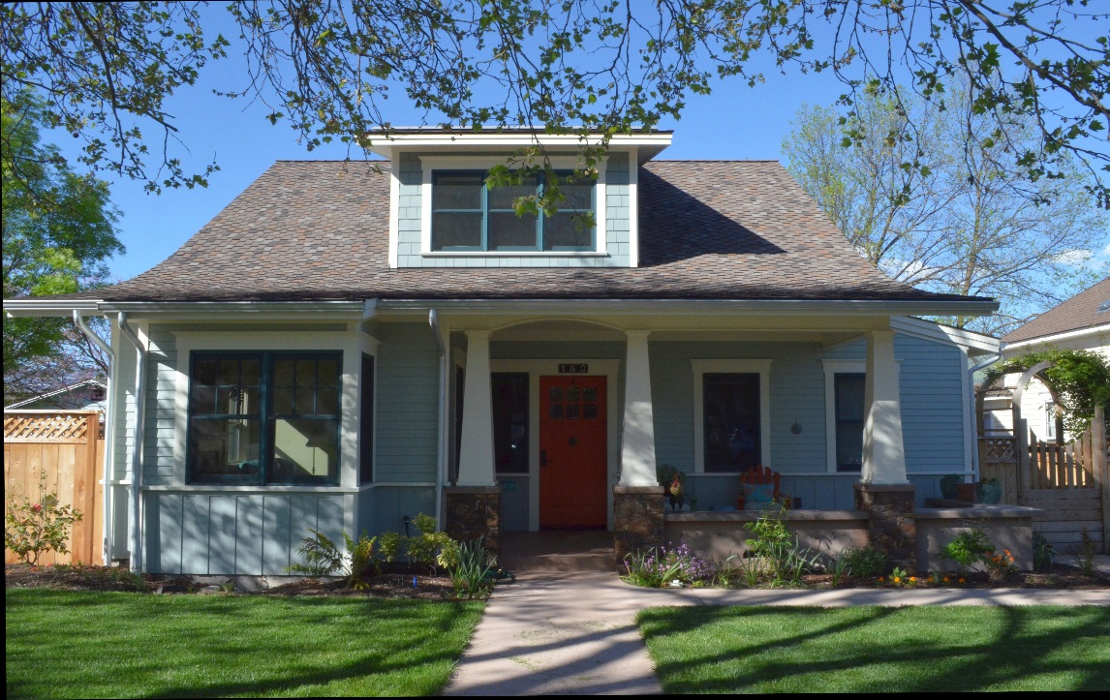
Historically Compatible Single Family Residence

Location: 160 Van Ness
Owners: Sean and Julie Downey
Contractor: The Downey Company
This property was purchased by Emma Hammond from Abel Helman in April of 1880. Emma built a house on the property (156 Van Ness), circa 1901, which is known as the Hammond House. She either lived there or rented the house after the death of her husband, A.P. Hammond, a prominent Ashland resident who served as Justice of the Peace and as Postmaster. By 1911, the lot was owned by Charles Hosley.

In 1920, Charles and Ella L. Hosley built two nearly identical small cottages to rent adjacent to the main house at 156 Van Ness. By 1948, Mr. Hosley divided the lot into three parcels, separating the twin cottages and the main house. All of the existing structures have remained virtually unaltered from their original design. They are Historic Contributing, have retained substantial integrity, and effectively relate to the period of significance.

Fourteen years ago, Julie Downey purchased the cottage and property at 160 Van Ness. She lived there part time and fell in love with the neighborhood. Four years later she had the opportunity to buy the neighboring twin cottage as an investment. At that time, both of the cottages were located side by side along Van Ness.

In 2015, Julie and her husband, Sean, decided to build a larger home and wanted to stay in the neighborhood. They decided to build adjacent to the Historic Contributing homes that they owned, however, they wanted to live along the street and not in the back alley. The lots that they own are narrow and very deep, which opened up the opportunity to relocate the cottages to the rear of the lots and along the alley. This allowed them to build their home along the Van Ness street frontage.

The new home, which was completed August of 2016, is historically compatible with the other adjacent Historic Contributing structures and with the surrounding neighborhood. Sean Downey designed the home as a 1 ½ story structure with traditional elements such as a gable roof and craftsman details. The design elements and quality materials were constructed by The Downey Company which is Sean’s personal business.

Sean and Julie Downey successfully designed, constructed, and finished a lovely home in the Skidmore Academy Historic District. This project exemplifies how preserving existing structures while building new adjacent structures can create a success for the owners and the neighborhood.

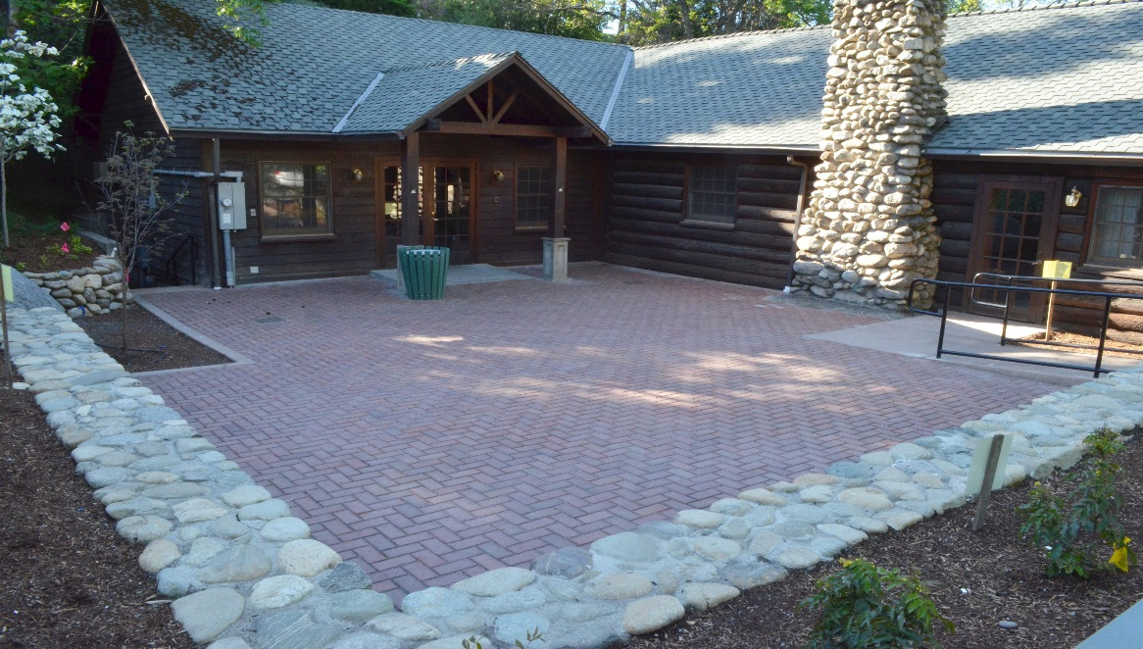
Civic Award

Location: 73 Winburn Way
Owners: City of Ashland, Parks and Recreation Dept.
Contractor: City of Ashland Parks Dept, City of Ashland Engineering & Electrical Depts, Covey-Pardee Landscape Architects & Table Rock Custom Homes and Masonry

Pioneer Hall was formerly known as the American Legion Hall where the American Legion Post No. 14 has meet since the 1920’s. The Hall was gifted to the City of Ashland in 1986 with the agreement that the Legion would retain exclusive rights for their scheduled activities in perpetuity. It was built sometime prior to the Community Center next door which was finished in 1922.

Pioneer Hall is owned by the City of Ashland and is leased to the Parks Department for management. Over the years the original brick paving in the courtyard was slowly damaged by tree roots that were lifting the bricks and creating trip hazards for the users. Some years back, and under budget constraints, the ‘short term’ fix was the installation of asphalt paving, painted red, to smooth the uneven areas which created quite an unsightly collage of the two materials.

Eventually the needed rehabilitation found its way to the top of the public works list and the City of Ashland’s Kaylea Kathol was assigned to manage the project. She hired Covey-Pardee Landscape Architects to provide three conceptual designs. The final choice included a concrete and cobblestone perimeter retaining wall that would additionally maximize the available seating in the courtyard. The designs also provided a concrete accessible ramp leading to the new thicker brick pavers that closely match the originals in color. The pavers have a wire cut texture with beveled edges for an added measure of safety to the walking surface.

Efren Regalado of Table Rock Masonry beautifully executed the concrete flatwork, stonework, and brick paving. He was also able to source additional matching stones needed to complete the more extensive walls. The Parks Dept. provided tree removal, irrigation, and installation for the mostly native plant species. The City of Ashland’s Dave Tygerson, Mike Cook, and Brad Barber provided the necessary electrical and engineering requirements.

The Historic Commission so appreciates the sensitivity and concern that Kaylea Kathol, Greg Covey, and Alan Pardee demonstrated throughout the process in creating this beautiful landscape design that maximizes both the function of the courtyard and complements the historic Pioneer Hall building.

